
Rossmoyne Senior High School
Semester Two 2011

Trial WACE Examination, 2011

Question/Answer Booklet

MATHEMATICS 2A/2B

Section Two:

Calculator-assumed

NAME:
TEACHER: Mr. Fletcher Mr Tanday

Time allowed for this section
Reading time before commencing work: ten minutes
Working time for this section: one hundred minutes

Materials required/recommended for this section

To be provided by the supervisor
This Question/Answer Booklet
Formula Sheet (retained from Section One)

To be provided by the candidate
Standard items: pens, pencils, pencil sharpener, eraser, correction fluid/tape, ruler, highlighters

Special items: drawing instruments, templates, notes on two unfolded sheets of A4 paper, and up to three calculators satisfying the conditions set by the Curriculum Council for this examination.

Important note to candidates

No other items may be used in this section of the examination. It is your responsibility to ensure that you do not have any unauthorised notes or other items of a non-personal nature in the examination room. If you have any unauthorised material with you, hand it to the supervisor before reading any further.

Structure of this paper

Section | Number of questions available | Number of questions to be answered | Working time (minutes) | Marks available | Percentage of exam
Section One:  Calculator-free | 7 | 7 | 50 | 50 | 33
Section Two:  Calculator-assumed | 12 | 12 | 100 | 100 | 67
 |  |  | Total | 150 | 100

Instructions to candidates

- The rules for the conduct of Western Australian external examinations are detailed in the Year 12 Information Handbook 2011. Sitting this examination implies that you agree to abide by these rules.

- Write your answers in the spaces provided in this Question/Answer Booklet. Spare pages are included at the end of this booklet. They can be used for planning your responses and/or as additional space if required to continue an answer.
- Planning: If you use the spare pages for planning, indicate this clearly at the top of the page.
- Continuing an answer: If you need to use the space to continue an answer, indicate in the original answer space where the answer is continued, i.e. give the page number. Fill in the number of the question(s) that you are continuing to answer at the top of the page.

- Show all your working clearly. Your working should be in sufficient detail to allow your answers to be checked readily and for marks to be awarded for reasoning. Incorrect answers given without supporting reasoning cannot be allocated any marks. For any question or part question worth more than two marks, valid working or justification is required to receive full marks. If you repeat an answer to any question, ensure that you cancel the answer you do not wish to have marked.

- It is recommended that you do not use pencil, except in diagrams.

Section Two: Calculator-assumed (80 Marks)
This section has twelve (12) questions. Answer all questions. Write your answers in the spaces provided.

Working time for this section is 100 minutes.

Question 8 (5 marks)
The cost of electricity, C in dollars, is directly proportional to the number of units of electricity consumed, N.

(a) Which one of the graphs below best show the relationship between N and C? (1 mark)

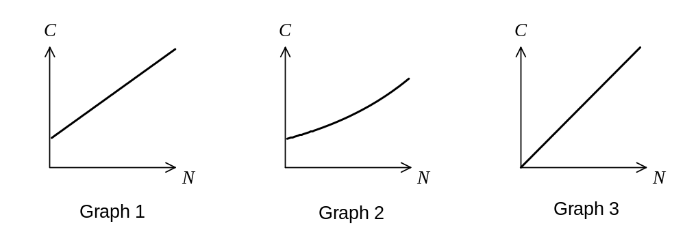

(b) If 540 units of electricity cost $102.06,

(i) how much will 270 units cost? (2 marks)

(ii) how many units of electricity could be bought for $94.50? (2 marks)
Question 9 (8 marks)
The distances, in metres, along direct paths between six campsites, A, B, C, D, E and F, are shown in the table below. Not all of the campsites have direct paths between them.

 | A | B | C | D | E | F
A |  | 50
B | 50 |  | 90 | 155 | 80
C |  | 90 |  | 75
D |  | 155 | 75 |  | 60 | 115
E |  | 80 |  | 60 |  | 180
F |  |  |  | 115 | 180

(a) Draw a network diagram to represent this information. (3 marks)

(b) Is the network above traversable? If yes, state where you would start and finish. If not, explain why not. (2 marks)

(c) List the shortest route to travel from campsite A to F along the above network of paths and state the length of this route. (3 marks)

Question 10 (9 marks)
As part of a study into the effect of exercise on health, the heart beat of 36 women were recorded after five minutes of weight-lifting. The results are shown in the table below.

Heart beat, (bpm) | Number of women
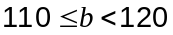 | 6
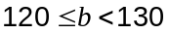 | 10
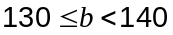 | 9
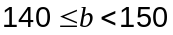 | 7
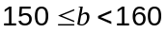 | 2
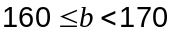 | 0
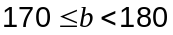 | 2

(a) Construct a frequency histogram for this data on the axes below. (3 marks)
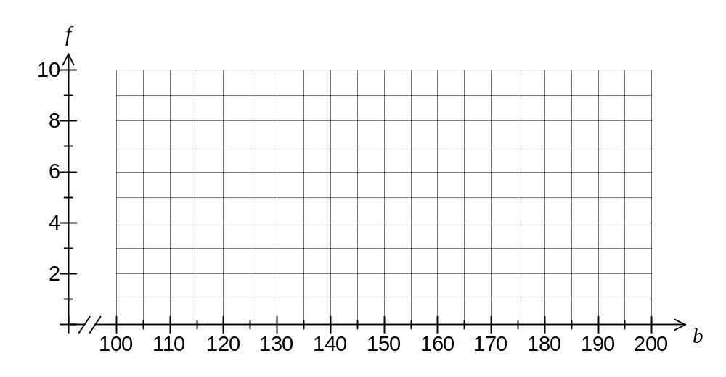

(b) Determine the mean heart beat for the group of women, rounding your answer to the nearest whole number. (2 marks)

(c) What percentage of the group had a heart beat of at least 140 bpm? (2 marks)

(d) Describe the spread of the data. (2 marks)
Question 11 (6 marks)
The unemployment rate in Australia from 1993 to 2006 is shown on the graph below.

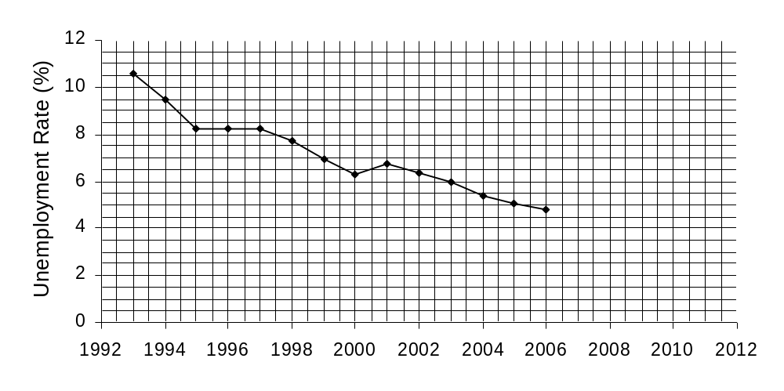

(a) Data for another four years is given in the table below. Use this data to extend the above graph until the year 2010. (2 marks)

Year | 2007 | 2008 | 2009 | 2010
Unemployment rate (%) | 4.4 | 4.2 | 5.6 | 5.2

(b) In which year was the unemployment rate 6%? (1 mark)

(c) Describe the trend in unemployment shown by the graph. (1 mark)

(d) In which year(s) did the unemployment rate not follow the trend? Explain your answer.
(2 marks)

Question 12 (10 marks)
A hardware store sells 300 mL cans of stain for $7 and larger 500 mL cans of the same product for $11.

(a) Which can of stain represents the best value? Show your reasoning. (3 marks)

(b) If the store bought the 300 mL cans for $5.60, what percentage profit do they make by selling them for $7? (2 marks)

(c) A customer buys 12 litres of stain for $272 by purchasing of the smaller cans and of the larger cans.

(i) Write an equation using and for the cost of the paint. (1 mark)

(ii) Write another equation using and for the amount of paint bought. (Note that one litre is the same as 1 000 mL) (2 marks)

(iii) Solve your two equations simultaneously to determine how many of each size can were bought. (2 marks)

Question 13 (10 marks)
Box A contains 3 tennis balls, 8 hockey balls and 12 cricket balls. Each of the balls in box A have the same chance of being chosen.

(a) What is the probability of choosing a cricket ball or a hockey ball from box A? (2 marks)

Box B contains 15 tennis balls, 11 hockey balls and 8 cricket balls. Each of the balls in box B has the same chance of being chosen.

(b) What is the probability of not choosing a cricket ball from box B? (2 marks)

(c) A hockey ball is chosen. From which box is it more likely to have come from, A or B? Justify your answer. (3 marks)

(d) 50 balls were selected at random from another box, C, each ball being returned to the box before the next was chosen. Of these 50, eighteen were tennis balls. If box C contained a total of 17 balls, with an equal number of tennis and hockey balls and the rest being cricket balls, what was the most likely number of each type of ball in box C? (3 marks)
Question 14 (10 marks)
A class of 25 students took examinations in three subjects: English, Mathematics and History.

One of the students was absent for the English examination. The two scatterplots below show the percentage scores for the 24 students who sat all three examinations.
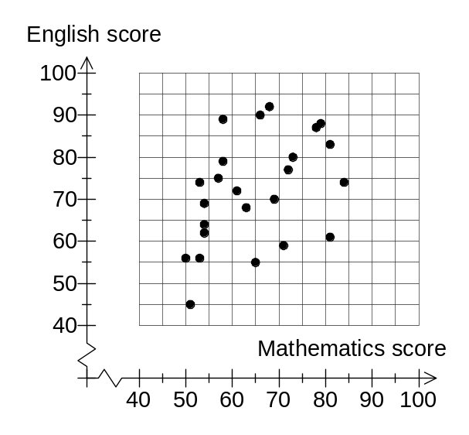 | 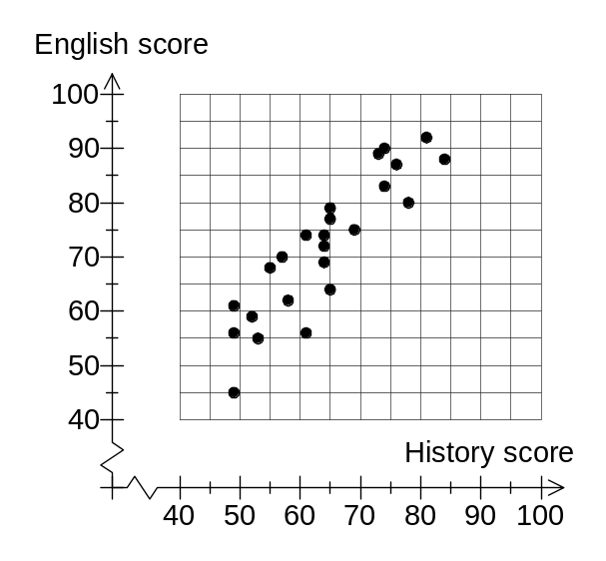

(a) What was the History score for the student who scored 65% in Mathematics? (2 marks)

The student who was absent for the English examination scored 70% in History and 75% in Mathematics.

(b) Which of the two scatterplots would be best to fit a trend line to, in order to predict the English score for the absent student? Explain your reasoning. (2 marks)

(c) Draw in a trend line on the scatterplot you chose in part (b). (2 marks)

(d) Show how to use your trend line to predict the English score for the absent student and write down this prediction. (2 marks)

(e) Comment on the reliability of your prediction in part (d). (2 marks)

Question 15 (6 marks)
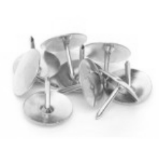
A box of 100 drawing pins was emptied onto a table in a random manner, with 37 landing pin up and the rest pin down. Some of the drawing pins are shown here.

(a) Estimate the probability of one drawing pin landing pin down. (2 marks)

(b) If a smaller box of 60 of the same type of drawing pins was emptied onto the table, how many would you expect to land pin down? (2 marks)

(c) If the original box of 100 drawing pins was emptied onto the table for a second time, and in a similar manner, would you expect 37 to land pin up again? Explain your answer.
(2 marks)

Question 16 (8 marks)
(a) A sphere has a radius of 5 cm and cube has a side length of 80 mm. Which solid has the greatest volume, and by how much? (4 marks)

(b) What is the side length of a cube that has the same surface area as a cylinder with a height of 20 cm and a radius of 8 cm? Round your answer to 1 decimal place. (4 marks)

Question 17 (8 marks)
Consider the triangle PQR drawn below.
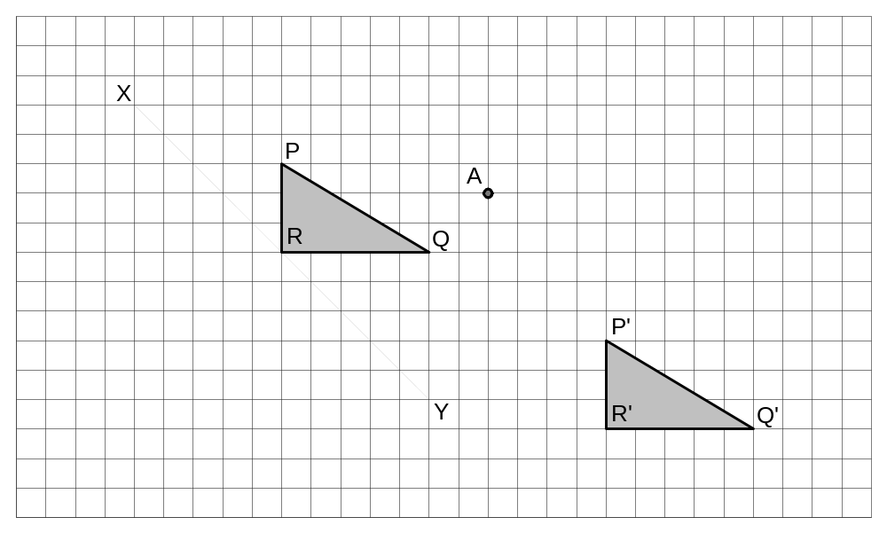

(a) Draw the position of triangle PQR after it has been reflected in the dotted line XY.
(2 marks)

(b) Draw the position of triangle PQR after it has been rotated 180° about point A. (2 marks)

(c) Describe the transformation of triangle PQR to triangle P'Q'R'. (2 marks)

(d) Consider this figure
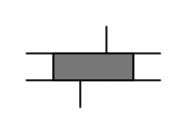
(i) How many lines of symmetry, if any, does this figure have? (1 mark)

(ii) What is the order of rotational symmetry, if any, for this figure? (1 mark)

Question 18 (7 marks)
Sheets of A3, A4 and A5 paper have a width to height ratio of 29:41.

(a) If a sheet of A3 paper has a width of 297 mm, determine the height of the sheet. (2 marks)

(b) How long is the diagonal of a sheet of A5 paper, which has a height of 210 mm? (3 marks)

(c) A sheet of A3 paper is cut along its diagonal into two congruent right triangles.

Use trigonometry to determine the size of the smallest angle in one of these triangles.
(2 marks)

Question 19 (13 marks)
Two students are simulating their own savings schemes for a 30 day period.

Anne starts off with $20 and plans to add $5 per day. She models her total savings, in dollars, with the relationship 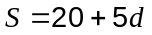, where is the number of days since she began saving.

Ben begins with just one dollar and plans to increase his total savings by 20% per day. He models his savings with the relationship 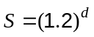.

(a) Show that after two days, Anne has $28.56 more than Ben. (3 marks)

(b) Plot the two relationships for the savings of Anne and the savings of Ben on the axes below for the first 30 days. (4 marks)

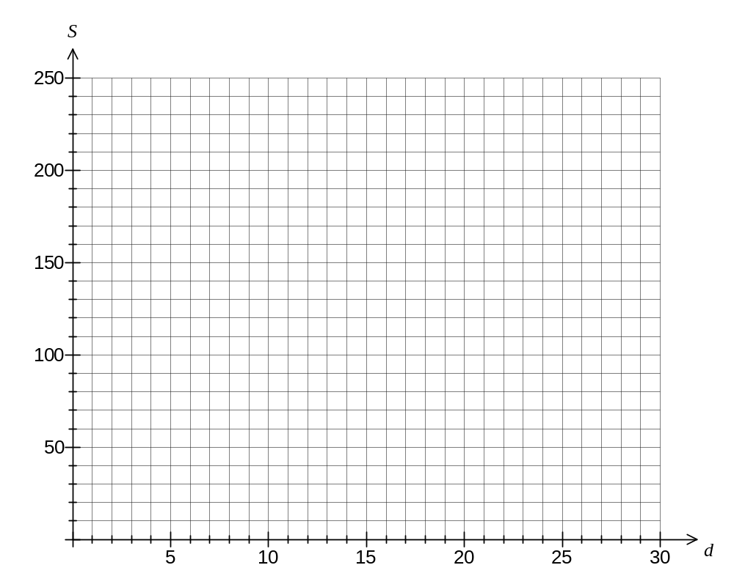

(c) From your graph, when have Anne and Ben both saved similar totals? (1 mark)

(d) Who has saved the most after 30 days, and how much more do they have than the other person? (3 marks)

(e) If Anne and Ben extended their savings schemes to run for 100 days, which scheme would you consider being the best? Explain your answer. (2 marks)

